Name : Keerthana.P
192521289

Topic
Concept Map 1: Cloud Computing Ecosystem and Core Components
Content / Description
This concept map illustrates the fundamental components of cloud computing and their relationships. It begins with Cloud Computing as the central concept, which consists of the Cloud Ecosystem, Cloud Actors, and Service Models. The Cloud Ecosystem includes computing, storage, network resources, and cloud services. Cloud Actors represent the stakeholders involved in cloud environments, such as providers, consumers, brokers, auditors, and carriers. Service Models define how cloud services are delivered through IaaS, PaaS, SaaS, and XaaS. These components rely on Virtualization, which enables the creation of virtual machines and containers. Virtualization supports Web Services, which communicate through REST APIs and SOAP APIs to provide cloud-based applications and services efficiently.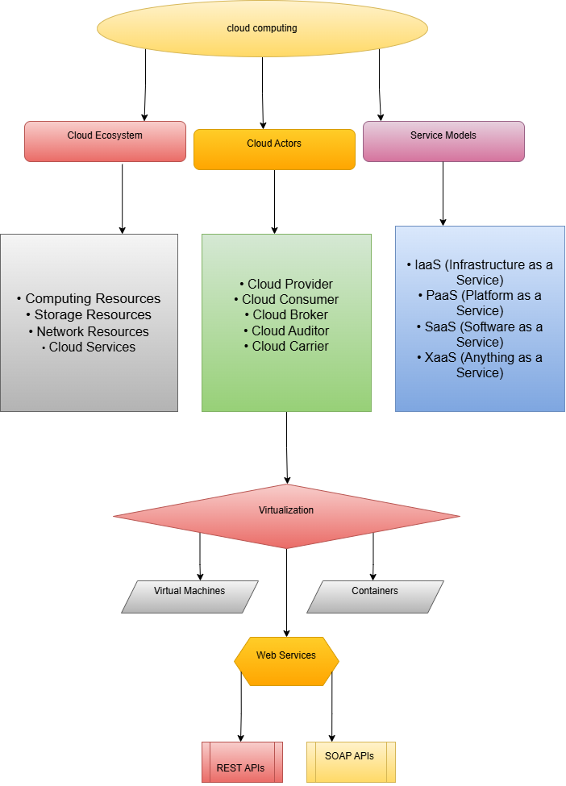
Short Content (for Report)
Cloud Computing Ecosystem and Core Components
This concept map presents the key elements of cloud computing, including the cloud ecosystem, cloud actors, service models, virtualization, web services, and APIs. Cloud resources and services are managed by different cloud actors and delivered through IaaS, PaaS, SaaS, and XaaS models. Virtualization enables efficient resource utilization using virtual machines and containers. Web services provide communication between applications through REST and SOAP APIs, forming the foundation of modern cloud-based solutions.
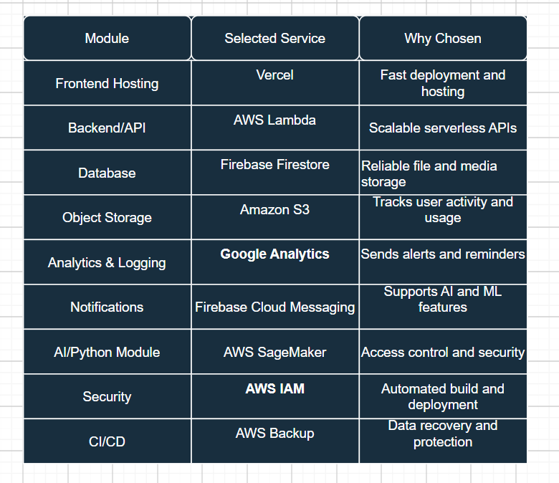

Title: Cloud Service Decision Matrix for Cloud-Based Online Learning Platform
Content
The Cloud Service Decision Matrix identifies the most appropriate cloud services for different modules of the Cloud-Based Online Learning Platform. Firebase Authentication is used to provide secure user login and registration. Vercel is selected for frontend hosting because it offers fast deployment and high availability. AWS Lambda manages backend APIs with automatic scaling and reduced infrastructure management. Firebase Firestore stores user information, course details, and learning records efficiently. Amazon S3 is used for storing videos, assignments, and other learning resources. Google Analytics helps track user engagement and application usage patterns. Firebase Cloud Messaging delivers notifications and reminders to students and instructors. AWS SageMaker supports AI and Python-based functionalities such as personalized recommendations and performance analysis. AWS IAM ensures secure access control and permission management. GitHub Actions automates software testing and deployment through CI/CD pipelines. AWS Backup provides reliable data recovery and protection, while Amazon CloudWatch continuously monitors system performance and availability. These services were selected because they offer the best balance of scalability, security, reliability, and cost-effectiveness for the project requirements.
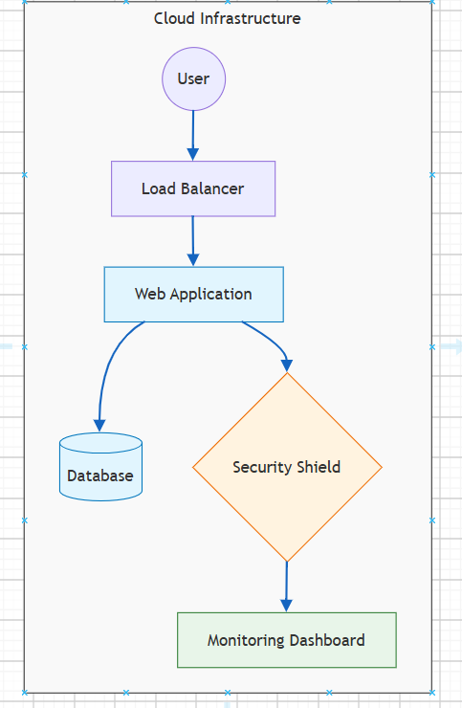

Title: API Flow, Elasticity, and Scalability Design for Cloud-Based Online Learning Platform
Content
This cloud-flow architecture demonstrates how users access the Online Learning Platform through a web or mobile application. User requests are first validated through the Authentication Service before reaching the API Gateway. The API Gateway routes requests to backend services running on scalable compute resources. Backend services interact with the database for structured data and object storage for videos, assignments, and learning materials. Analytics and logging services collect user activity and system logs, while monitoring services track performance and availability. Security boundaries protect all components through authentication, authorization, and network controls. Elasticity automatically adjusts compute resources based on workload, while scalability allows the system to handle increasing numbers of users during peak learning periods.
